Last week: packet switching

This week: congestion control

Congestion control is resource management: assigning limited resources of link rate to flows

* TCP: flow-controlled bidirectional byte stream
  + The speed is regulated by link_rate at the beginning. The steady state is limited by min(link_rate, how fast the reader is draining the byte stream (window_size)).
* Single-flow, single-hop model  
  S(ender) —--------- X(router) —---------- R(receiver) with r = 1 Gbit/s and propagation delay = 1 second
  + The sender sends a datagram, still waiting for the corresponding ackno, where could the datagram be (in the sender’s mind):
    - Propagating on the link
    - Waiting at the router queue (bottleneck queue)
    - Could have been received by the receiver, but ackno still on the way back
    - Or the datagram or the ackno is lost/dropped
  + Outstanding segments from the sender’s perspective: [ackno, ackno + window_size)
  + Window_size: cap on the number of “outstanding” bytes
    - “Outstanding” means sent, not acked or judged lost
  + Q: what if the window size is really small?  
    A: throughput $\frac{1 byte}{2 * propogation delay} = 0.5 byte/s (if propogation delay = 1 s)$ (RTT = 2*propogation delay)
  + Q: what if the window size is gigantic?  
    A: maximum throughput: 1 Gbit/s and the router may run out of memory or huge queueing delay.  
    We call this **congestion.**
* Congestion is bad
  + Congestion collapse (in the 1980s): receivers were advertising large window_size and forced the router to drop lots of packet
  + Or some flows send too much, others are starved. There is an issue for fairness.
* Useful work should increase as demand increases. It’s okay if the derivative is less than 1, but it should not be the case that the derivative is negative.
  + Single-flow, single-hop model would not have a collapse, since the throughput stays at 1 Gbit/s even if many packets are dropped
  + The “collapse” issue:
  + 
  + If there is only 1 flow: S2 → R2, throughput would be 100 Mbit/s
  + If there is two flows: S → R and S2 → R2, throughput would be ~51 Mbit/s if S sends at 100 Mbit/s (COLLAPSE)
  + If there is two flows: S → R and S2 → R2, S sends at 1 Mbit/s and S2 sends at 99 Mbit/s. Throughput would be 100 Mbit/s
  + The “fairness” issue:
  + 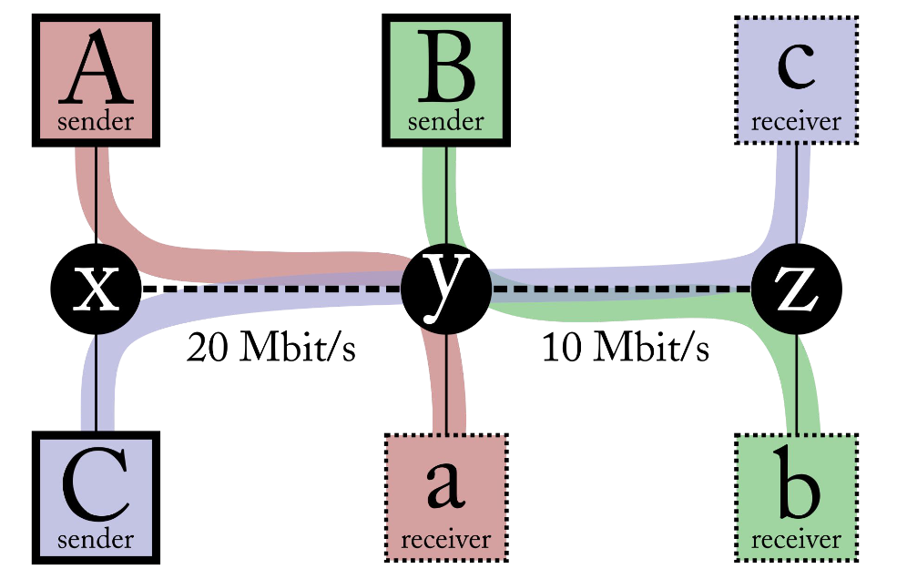
  + A -> a, B -> b, C -> c, total  
    15, 5, 5, 25 max-min fair  
    20, 10, 0, 30 max utilization/efficiency  
    16, 6, 4, 26 proportionately fair   
    0, 0, ~~20~~10, 10 congestion collapse
  + The objective: maximizing a utility function: $max_{\{x_{r}\} ∈S }\sum_{r}{}U_{r}(x_{r})$ and $U(x) = \frac{x^{1 - α}}{1 - α}$
    - $α= 0$, max utilization
    - $α → 1$, proportional fairness
    - $α =2$, min-potential-delay fairness
    - $α →inf$, max-min fairness
  + Other objectivesL
    - Minimize flow completion time (of average download)
    - Minimize page load time (with many download flows)
    - Maximize “power” (= throughput / delay)
* Algorithms to prevent collapse are called “**congestion control**”
  + What is the right window size?
  + How should flows learn the window size?